**Semester(5th) Project**

**Phase-1 Report**

## Project Title:

## SafeCase - To Design a Multipurpose Security device for personal and objective security.

## Group Member:

1. DeveshSehgal(19BEC1082)
2. Pankaj Kumari (19BEC1080)
3. SushantKumar(19BEC1078)

**Literature survey:**

Violence, Thefts, Missing persons account for over millions of registered cases each year, this data bellows shows exactly what we are dealing with right now.

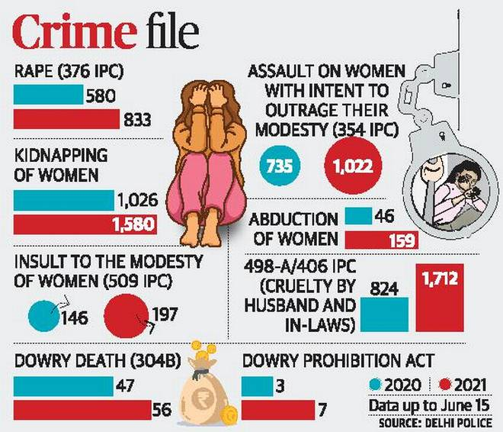

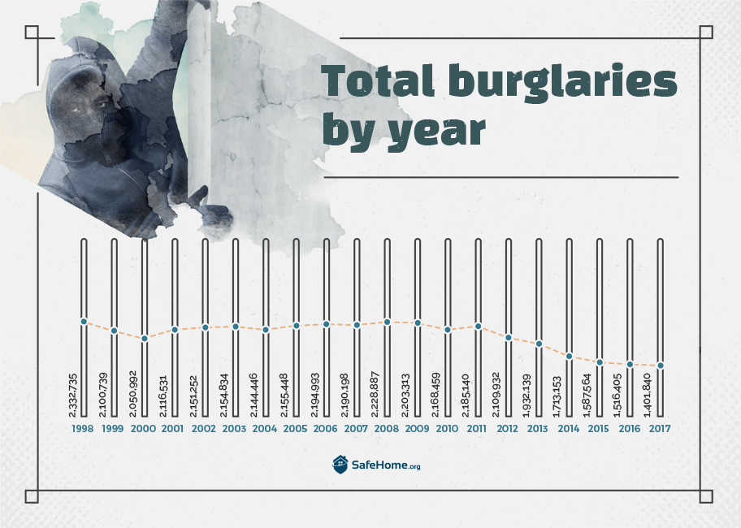

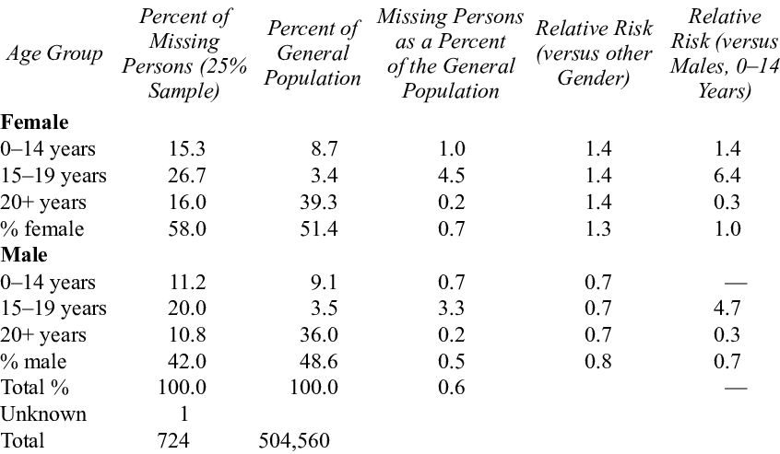

1.) First Data set was collected in just one city of India i.e. New Delhi , It shows how vulnerable women are in today’s society while some and the given data further indicates much of that was preventable if necessary help be it small or big , was there in given time.

2.) Second Data set talks about the burglary cases around the world, being one of the worst crimescommitted under theft even though being very much preventable and easy to prevent but it still stays as one of most common crime.

3.) Last Data set is about percent of people missing where a large number of missing people are due to things like abduction and such a small part of it is also contributed by the people lost to unknown causes.

Much of society’s resources are devoted to dealing with, or preparing for the safe keep of us Humans and after thorough research and studies we came up with an idea to design a multipurpose safety case concerning these three crimes and how to prevent it by taking necessary measures.

**Objective:**

A small Case/Box with the objective for Multipurpose Security for personal and remote usage. Basically, it would be a very compact and multipurpose device which can be utilized in various ways with main objective to save lives consisting of GSM and GPRS integrated with motion controlled SOS feature. Usage of this device would be heavily focused for people in extreme need for saving and females to keep themselves safe and secure at crucial times.

Nowadays, people are very concerned towards their secret things, so this device will send you a location and a private message, if someone touches your box.

It can also be used as a home security purposes. We can attach it to the main door or windows, when you are outside. If someone tries to open the window or door house, this device will provide you a message that someone tries to open it. So you can complaint or you can reach at time.

We will use single button feature to access these operations. Anyone can operate this by just clicking the button number of time according to their need.

* By pressing the button **once**, we can access the device for People Safety. By operating this, our device will send location to their relatives and concerned authorities.
* By pressing the button **twice**, the device will work on search and rescue operation in which device provides both location and private message.
* By pressing the button **thrice**, the device can be used as home security purposes and protecting secret things in which all the three features of device will work at same time i.e. sending location, provide private message and thief alerting buzzer.

**Details:**

A rough diagram can be drawn out of the following circuit diagram for now.

From Following Circuit we can see the different sensors and equipments used such as:

First a Button to select selected mode from three modes of actions, While the Atmega328P acts as the brain of the entire circuit, a Three axis gyroscope, Accelerometer and a motion activated vibrating sensor acts as the initiator for the Case , a GSM and GPRS module acts both as a locator and signal sender.

Buzzer is to create necessary noise to attract attention of bystanders and even scare of potential harmful elements.

